

International Journal of Solid Mechanics and Materials Science, 1 (x) (2019) xxx-xxx

International Journal of Solid Mechanics and Materials Science

Website: http://www.sigma-src.com/publication/ijsmms

EFFECT OF EXTERNAL HEAT ON THERMOPLASTIC

USING FRICTION STIR SPOT WELDED PLATES
I.H. Noorazman, M. Awang*, R.S. Khairi ,H. Safian
*Mechanical Engineering Department
Universiti Teknologi PETRONAS
32610 Seri Iskandar, Perak
Malaysia
mokhtar_awang@utp.edu.my

Abstract

Thermoplastic or known as polymer is known for its light weight property which was used in varies industry and used in the industry as a substitution for metal. Thermoplastic was the only polymer that can be welded. Friction Stir Spot Welding (FSSW) is a revelation of Friction Stir Welding (FSW) where it only need to plunge the tool at one point and create the joint. So, the purpose of the this investigation was to analyze the influence of the external heat on the tensile strength and to analyze cross section of friction stir spot welding (FSSW) joints produced on high-density polyethylene (HDPE) sheets. The analysis involved the variation of the temperature of external heat and constant rotational speed, tool plunge rate, pre-heat time and dwell time. The type of joint was single lap joints of two similar material. Mechanical characterization of joints of welded joint was carried using a lap shear test. Experimental tests were conducted to determine the most influencing factors which in this case, the external heat factor to determine the mechanical behavior of FSSW joints. The result for lap shear test was sample with external heat of 50 Celsius have the highest stress compared to others external temperature. After the lap shear test, welded joints was observed by its cross section and the result was sample with external heat of 70 Celsius has highest material movement around the welded joint with the result of percentage void of 75 percent.. The conclusion for this experiment is external heat improves the strength of the welded sample at the highest with using external heat temperature of 50 Celsius. The external heat also resulting in varies of weld surface finish, lower chip formation, and material loss. This method overcomes the insufficient heat which always leads to improper fusion and lack of weld formation.

Keywords: Friction stir spot welding; Thermoplastic; HDPE; Cross section analysis; Lap shear strength; External heat

- Introduction
Thermoplastic or known as polymer is known for its light weight property which is used in varies industry. Due to high demand from industries as a material substitution for metals, thermoplastic material are now used with several type of joining. Friction Stir Welding (FSW) is a welding process which the tool is rotating at a high speed and slowly plunged into the work piece and moved linearly while Friction Stir Spot Welding (FSSW) is a revelation of FSW where it only need to plunge the tool at one point and create the joint of limited size based on the tool geometry. Both of this method uses the same way to generate the heat using friction by the high rotation speed and the material work piece experience plastic deformation which soften the work piece. Among three kinds of polymeric materials; thermoplastics, thermosets, and elastomers, only thermoplastics are the weldable polymers. It is due to their ability to be reshaped after heating below their degradation temperature.
Thermoplastic or known as the polymer material is used in the various industry such as electronics, automotive, aerospace, and packaging [13] as an alternative to the usage of metals. This is because of the lightweight characteristic of polymer and it can achieve the same amount of tensile strength of the metal. There are some of the thermoplastic material that usually tested on welding capability for instance high density polyethylene (HDPE), polypropylene (PP), polymethylmethacrlyte (PMMA) and acrylonitrile butadiene styrene (ABS) [8]. Recently, FSSW method has been developed on thermoplastic and the result is a high quality of joint over conventional welding [3]. FSSW is similar to resistance spot welding (RSW) but in FSSW it only requires the plunge and tool retraction process which is a minimal process [10] compared to other single joint processes. The advantages of FSSW are it uses less energy, reduction of the cost up to 40% to maintain the equipment due to minimal equipment requirement and environmentally friendly due to the absence of fumes or sparks [3]. Below are the steps of FSSW method.
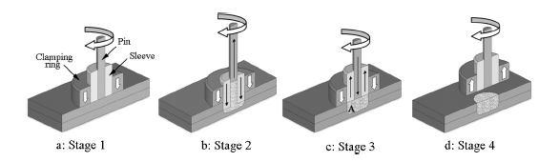
Fig 1: Schematic Illustration for FSSW process [11].

Welding on polymers is hard due to different physical and rheological difference for each polymer. One of the challenge when welding polymers is achieving optimum process parameters. Rotational speed is a major process parameter which different for each kind of material dependent on the physical properties. A high rotation will produce the result of degradation of polymer while lower rotation speed gives poor mixing thus resulting voids in the work place. Therefore, the need to investigate the optimum parameters for each polymer is vital [13].
For this project, high density polyethylene (HDPE) material will be used. HDPE is the closest type polyethylene to the pure polyethylene. It consists of unbranched molecules with small flaws to mar its linearity. HDPE is also known as a typical material with an exceptionally low level of defects and high level of crystallinity which make it a type of resin with high density compared to other types of polyethylene. The combination of highest stiffness and lowest permeability of all the types polyethylene make HDPE good for containment product. It also can be used piping, water, and natural gas transportation due to corrosion resistance to the surrounding. It has high tensile strength for load-bearing film application such as food storage container, crates, and toys. Liquid and solid waste containment pits can be made using HDPE as chemical resistance is one of the properties of the material.
Temperature in one of the critical aspect for FSSW method. Most FSSW welded material of metal give a significant result because of the characteristic of metal which is a good conductor and thermal conductor. The result of a metal work piece will not be the same with thermoplastic material. This is due to nature of thermoplastic which are bad conductor and thermal conductor [9, 10]. In other way, thermoplastic material need a higher temperature during the pre-heat phase to make sure it undergo thermal diffusion and bond to each plate. Effect of lack of heat during FSSW with thermoplastic material will lead to improper fusion and void formation [9].
The effect of tool geometry is on the plastic flow and material mixing during FSSW [5]. The effect on the material flow of tool surface features, welding conditions is rotation speed, plunge depth, dwell time [12], Tool and pin play a major role in material flow, stirring and weld quality in FSSW 14]. Figure below showed three type of pin threaded pin, pinless pin and flat tip pin. Different pin will have different result based on their geometry which will be the factor of the material flow during welding. The weld microstructures varied significantly depending on probe length, tool rotational speed and tool holding time [2].
Welding parameters used to play an important part with the microstructure and the quality of the weld [13]. The workpiece experiences of warming which results in changes of microstructural changes and distinctive zones arrangement. For metal, there are four different zones: the weld nugget (WN), thermomechanically affected zone (TMAZ), heat-affected zone (HAZ) and base material (BM). However, in the case of polymers, not all of zones formation are present because of the difference of characteristic of polymers to metals. Polymer such as HDPE high level of crystallinity and lower branching characteristic as nature

- Materials and methods

2.1. Materials

For this project, thermoplastic material that will be used is high density polyethylene HDPE) for dimension of as per below with thickness of 2mm.

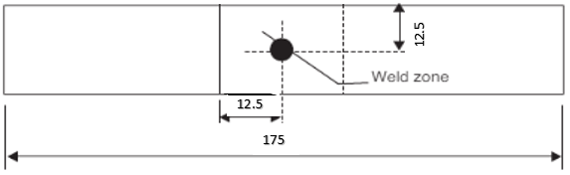



Fig 2: Dimension for HDPE material

2.2. Apparatus and procedure

2.2.1. Tool geometries

The tool is known as straight cylindrical pin. The threaded pin has a depth 0.1mm on the 20mm shoulder surface. The ideal probe length or depth from the shoulder for the standard threaded pin tool in making the highest tensile-shear strength of welds is 3.8mm [12] which eighty percent of the total thickness (4mm) of combined material.. Below is the figure shows the tool that will be used in the project.

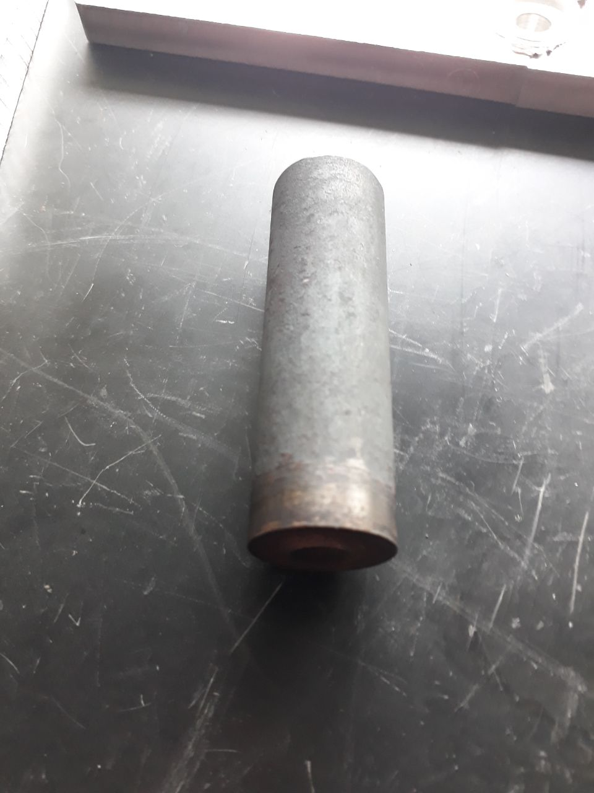

Fig 3: Straight cylindrical pin

2.2.2. Welding parameter
In this project, the process variable are very important factor to the welded material. The tool rotational speed, dwell time and depth of plunge of the shoulder are the most common variables used FSSW. Each tool have different optimum processing condition, so the processing condition for this project were studied and collected based on past research paper. Other than that, external heat also will be the parameter for this project. Below are table of welding parameter.
Table 1: Welding Parameter
Parameters | Value
External Heat (Celsius) | 30,50,70
Speed (RPM) | 600
Dwell Time (sec) | 20
Pin Shoulder Diameter (mm) | 20
Pin Tip Diameter (mm) | 10

2.2.3. Pull test

Pull tests are one of the suitable type of testing for welded material due to lower load during the pulling test. The test were done in order to assess the condition of welds based on the strength. The lap-shear specimens according to ASTM D3163 were made by using two identical plate in the center of which FSSW was performed. In order to identify the strength of the specimen, all the specimen will go through pulling test to find the amount of forces needed to make the specimen tear. The forces of each specimen should be different.

2.2.4. Cross section analysis

Cross section analysis was the last process of this project. The purpose of this analysis is to check the FSSW on the welded material. Before the analysis started, the welded specimens undergo several steps. The specimens need to be cut into half before goes into the grinding process. Next, specimens were going polishing etching process. This needed to be done because the specimens must be free from any contaminants for better results.

2.2.5. Method

High Density Polyethylene (HDPE) sheets of dimension100 mm × 20 mm × 2 mm were joined using friction stir spot welding method to test the effect of the variation of external heat temperature. HDPE is a light weight engineering material that finds application due to its low cost, low thermal conductivity, and high resistance to any condition. The HDPE sheet were clamped in a wooden fixture on top of the platform of the machine before the weld process start. After all the steps are followed, the welding can start with the required processing condition. Several trials are done before to see the result based on the processing condition. After using the correct welding processing condition, all the specimens are qualified for its tensile/pull testing and cross section analysis.

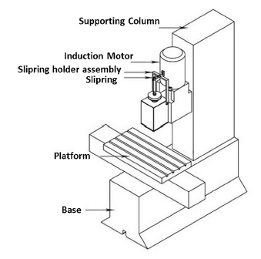

Fig 4: Friction stir spot welding machine

- Results and discussion

In this project, the main objective is to see the strength of welded joint using lap shear testing and analyze the effect of different of external heat on the cross section of the sample. The external heat play an important role on the result of these two objective.

3.1. Lap shear testing

The result from graph from lap shear strength testing on UTM machine indicates there are changes in stress, MPa based on the external temperature. This show that the difference of external temperature before the welding process start do have effect on the strength of welded joint of the material. Figure 5, 6 and 7 below show the strength of the welded joint in graph for each added external temperature before the welding process begin. Based on the result, HDPE material needed a little extra heat to make better weld region with higher strength but too much extra heat will resulting of weaker weld region with a lot of voids at the material.

Fig 5: UTM results for sample HDPE with external temperature of 30 Celsius

Fig 6: UTM results for sample HDPE with external temperature of 50 Celsius
Fig 7: UTM results for sample HDPE with external temperature of 70 Celsius
For each set of sample, it consist of 5 samples of HDPE material. From the result of each sample, the ultimate tensile strength or the peak stress of the material for each set of sample. From the average value of the peak stress, it can be said that the external temperature affected the welded strength joint. Table 3 below show the comparison between the average value of the peak stress and elongation at break with original value of HDPE.
Table 3: Comparison of ultimate tensile strength and elongation at break of the HDPE material of original and experimental values.
HDPE | Ultimate Tensile Strength, MPa |  |  | Elongation at Break, %
Original Value | 15 |  |  | 500
Sample  1,2 and 3 | 2.74 | 2.77 | 1.48 | 1640 | 1820 | 910
Difference in percentage, % | 18.3 | 18.5 | 9.9 | 328 | 364 | 182

3.2. Cross section analysis

For cross section analysis, the main purpose of this analysis is to see the material movement of the HDPE after welding especially on the welded region. However, the analysis were taken only using the naked eye and not special tool or equipment that can examine the material even more detail because of the finishing of the welding of HDPE were not up to expected. So by examine these characteristic below, the finishing product itself will have some relationship with the strength of the weld material:

3.2.1. Length of deflection of top material
During the experiment, the top material were moving upward resulting of the spinning of the tool especially during the welding. The speed does not affect the movement of the top of material as the speed of the tool was kept constant for all the sample. The difference variable for this experiment was the external heat temperature. This show the external heat have some relationship with the movement of the material.

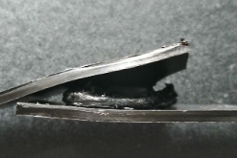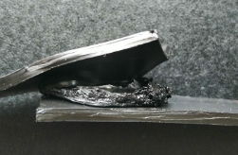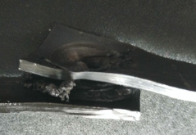
Fig 8: Deflection of top material for sample HDPE 1, 2 and 3

Table 4: Height of deflection of top material
 | Sample HDPE 1 | Sample HDPE 2 | Sample HDPE 3
Height of deflection of top material | 1-1.3 cm | 1-1.5 cm | 0.8-0.9 cm

3.2.2. Diameter of semi-circle of the bottom center
The bottom material produced a dent or semi-circle shape at the bottom material at the end of the experiment. The change of shape was caused by the material movement at the tip of the tool. During the penetration of the tool, the bottom material was pushed down and the semi-circle shape was the result during the retraction of tool pin. The semi-circle shape then stay fix in this shape after it has been cool down.

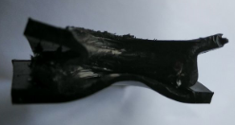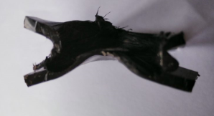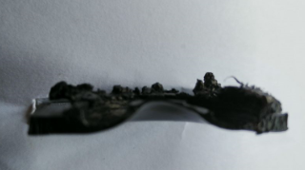
Fig 9: Semi-circle shape of bottom material for sample HDPE 1, 2 and 3

Table 5: Radius of Semi-Circle of Bottom Material
 | Sample HDPE 1 | Sample HDPE 2 | Sample HDPE 3
Radius of Semi-Circle | 0.3 cm | 0.3 cm | 0.4 cm

3.2.3. Amount of flash around the welded region

Sparks were produced around the welded region. The amount of spark produce varies based on the external temperature. Sample HDPE with external temperature of 50 Celsius has the highest amount of spark while sample HDPE with external temperature of 70 Celsius has lowest amount of spark. The high temperature will cause some of the material loss from its original material. This result can be seen on sample HDPE with external temperature of 70 Celsius. The amount of spark on sample with external temperature of 50 Celsius was more compared to the sample with external temperature of 30 Celsius because plastic need some heat because of low thermal conductivity so that it can welded together better.

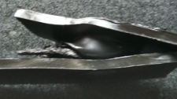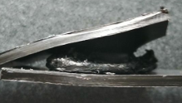

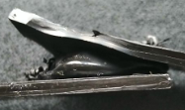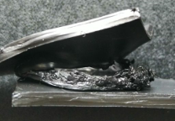

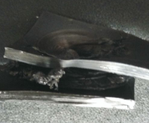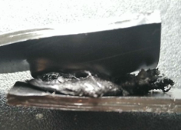Fig 10: Spark at the welded region for sample HDPE 1, 2 and 3

Table 6: Amount of spark at welded region
 | Sample HDPE 1 | Sample HDPE 2 | Sample HDPE 3
Amount of spark | Medium | Large | Small

3.2.4. Size of void at the welded region

Void will always present at welded region if the welding are not perfect. So in this experiment, void are present at welded region but differently based on the difference of external temperature applied on the material. Table 13 show the percentage of void at the welded region and Figure 10 above also show the visual result of the void for each sample.

Table7: Percentage of void at welded region
 | Sample HDPE 1 | Sample HDPE 2 | Sample HDPE 3
Percentage of void | 22 % | 48 % | 75 %

- Conclusion
The external heat improves the strength of friction stir welded of High Density Polyethylene (HDPE) material at temperature of 50 Celsius compared to other external temperature. The external heat provides additional heat during FSSW to result in varies of weld surface finish, and lowers chip formation and material loss. This method is capable of overcoming the insufficient heat which used to result in improper fusion and lack of weld formation.
- Recommendation
Even though the results approves the objective of the project, the highest peak stress of the welded material is still lower compared to the original material (HDPE) itself. This is due of the poor clamp system during the welding process. So, the recommendation for this project to improve the result is to use or fabricate a specialized clamp in order to reduce the material movement during the welding.
Acknowledgement
I have taken efforts in this project. However, it would not have been possible without the kind support and help of many individuals and organizations. I would like to extend my sincere thanks to all of them. I am highly indebted to Assoc. Prof. Ir. Dr Mokhtar bin Awang for his guidance and constant supervision as well as for providing necessary information regarding the project & also for their support in completing the project. I would like to express my gratitude towards my parents for the encouragement which help me a lot in completion of this project. I would like to express my special gratitude and thanks to the technician, Mr Hafiz for giving me such attention and time during my project. My thanks and appreciations also go to my colleague which have willingly helped me out throughout the project.
References
- J. Gonzales, J. dos Santos, L. Canto and S. Amancio_Filho, "Friction spot welding of carbon fiber-reinforced polyamide 66 laminate," Materials Letters, pp. 506-509, 2015.
- Y. Tozaki, Y. Uematsu and K. Tokaji, "Effect of tool geometry on microstructure and static strength in friction," Machine Tools & Manufacture 47, pp. 2230-2236, 2007.
- A. Paoletti, F. Lambiase and A. Di Ilio, "Optimization of friction stir welding of thermoplastics," Procedia CIRP 33, pp. 562-567, 2015.
- A. Yousefpour, M. Hojjati and J. Immarigeon, "Fusion Bonding/Welding of Thermoplastic Composites," THERMOPLASTIC COMPOSITE MATERIALS, 2004.
- A. Paoletti, F. Lambiase and A. Di Ilio, "Analysis of forces and temperatures in friction spot stir welding of thermoplastic polymers," Advanced Manufacturing Technology, pp. 1395-1407, 2016.
- S. Hirasawa, H. Badarinarayan, K. Okamoto, T. Tomimura and T. Kawanami, "Analysis of effect of tool geometry on plastic flow during friction stir spot," Materials Processing Technology, pp. 1455-1463, 2010.
- Y. Tozaki, Y. Uematsu and K. Tokaji, "A newly developed tool without probe for friction stir spot welding and its," Materials Processing Technology, pp. 844-851, 2010..
- R. Kumar, R. Singh, I. Ahuja, R. Penna and L. Feo, "Weldability of thermoplastic materials for friction stir welding- A state of art," Composites Part B, pp. 1-15, 2018.
- P. N. Banjare, P. Sahlot and A. Arora, "An assisted heating tool design for FSW of thermoplastics," Materials Processing Technology, pp. 83-91, 2017.
- F. Lambiase, A. Paoletti and A. Di Hio, "Mechanical behaviour of friction stir spot welds".
- Shen, Z., Yang, X., Yang, S., Zhang, Z., & Yin, Y. (2014). Microstructure and mechanical properties of friction spot welded 6061-T4 aluminum alloy. Materials and Design, 766
- A. Reilly, H. Shercliff, Y. Chen and P. Prangnell, "Modelling and visualisation of material flow in friction stir spot," Materials Processing Technology, pp. 473-484, 2015.
- A. Zafar, M. Awang and S. R. Khan, "Friction Stir Welding of Polymers: An Overview," 28 August 2018. [Online]. Available: https://www.researchgate.net/publication/316593509.
- A. Garg and A. Bhattacharya, "Strength and failure analysis of similar and dissimilar friction stir spot welds: Influence of different tools and pin geometries," Materials & Design, pp. 272-286, 2017.
- M. Bilici and Yukler AI, "Influence of tool geometry and process parameters on macrostructure and static strength in friction stir spot welded polyethylene sheets," Mater Des 33, pp. 145-152, 2012

