
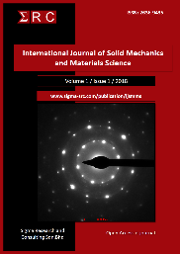
International Journal of Solid Mechanics and Materials Science, 1 (x) (2019) xxx-xxx
International Journal of Solid Mechanics and Materials Science
Website: http://www.sigma-src.com/publication/ijsmms

VERTICAL COMPENSATION FRICTION STIR WELDING USING SIMILAR AND DISSIMILAR FILLER MATERIALS
R.S. Khairi, *M. Awang, I.H. Noorazman,H. Safian
¹Mechanical Engineering Department
Universiti Teknologi PETRONAS
32610 Seri Iskandar, Perak
Malaysia
mokhtar_awang@utp.edu.my
___________________________________________________________________________________________________Abstract
Nowadays, many applications involved in using similar materials to be combined required engineering application. It is a challenging thing to achieve as every material has its own thermal, mechanical and electrical properties which need to be considered before fabrication is done. FSW is the best choice to join dissimilar material such as aluminium alloy and copper. Consequently, poor joint strength at welded part that can be found in literature review by FSW has been found as a problem. The objectives of this paper are to investigate the microstructure of the vertical compensation friction stir welded joint and to study the effect of filler material on the strength of the welded joint. The scope of study in this project is within the aspect of FSW, aluminium alloy, copper alloy, microstructural examination and tensile test. The manipulated parameter in this project is the filler materials. The type of joint that was used is butt joint with filler in between 2 base materials. The welded samples were cut to execute for microstructural examination and tensile test according to its standard. The microstructural properties of the joints were examined optical microscope (OM) and tensile test by using UTM. Experimental test was done to find out the most influencing factor which is filler material factor to determine the strength of VCFSW. After the tensile test, the welded joints were tested with microstructure analysis to study the structure of material under OM and SEM. The grains in the DCZ experienced recrystallization and changed in grain boundaries size. The tensile strength for fillers of AA1100, AA7075 and Cu C1100 obtained 101.402MPa, 127.28MPa and 11.308MPa respectively. In conclusion, the joint between AA7075 filler and AAA6061 plates obtained the strongest joint of all the joints with 127.28 MPa peak stress. The joint between copper filler and AA6061 plates obtained the least strength with 11.308MPa peak stress. Finally, few recommendations were inserted for further study of regards of joining dissimilar materials.
Keywords: Friction stir welding, dissimilar material, tensile, microstructure, joint strength ______________________________________________________________________________________________________________
1. Introduction
Friction stir welding (FSW) is a solid-state joining process that was invented and experimentally proven at The Welding Institute (TWI) in the United Kingdom in December 1991 [1]. It uses a non-consumable tool to join two facing work pieces by using only heat generated from friction. Heat is generated by friction between the rotating tool and the work piece material, which resulted FSW tool region to be softened. While the tool is traversed along the joint line, it mixes the two pieces of two metal, forged and softened by mechanical pressure. Aluminium alloy has been used widely in industries such as transportation, nuclear spent fuel storage and neutrons capturing work [2]. In general, Cu possess good electrical conductivity and normally people use this material to manufacture electric cable and electrical applications [3]. To join between Al and Cu can cause big number of Intermetallic composites (IMC) in different weld zones which means these are unique metals that have attributes of brittle, hard and lower strength [4]. In addition, fusion welding method is not suitable for these materials due to solidification and liquefaction cracking from the weld defects [5]. Nowadays, most of the manufacturing industries require variety of properties that are used to produce a single component or structure [6,7]. This method has been used widely in industry especially in automotive industry, spacecraft, train and shipbuilding. What makes different in this project is the author will validate the result in checking of the joint strength by applying strip in between two aluminium alloys just like Fig 1.
Filler
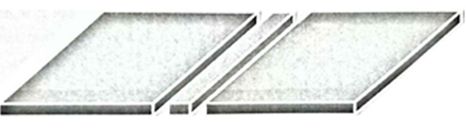Fig 1: Tailor welded blank with additional material using VCFSW
2. Materials and mehods
2.1. Materials
This study is focusing on the behaviour of several filler materials which are of AA1100, AA7075 and Copper Alloy Cu (C1100) towards the strength of the friction stir welded joint of 2 base metals which are aluminium alloy AA6061 and the microstructural images formed.
B. Apparatus and Procedure
The welding tool that will be using is E132 stainless steel threaded pin with 4mm height of pin with shoulder diameter of 15mm for AA1100 and AA7074 filler while for speed are at 600rpm and 15mm/min, respectively for AA1100 filler and AA7075 filler. For copper filler, the rotational and traverse speed are 800rpm and 15mm/min respectively. The tools are shown in Fig 2.
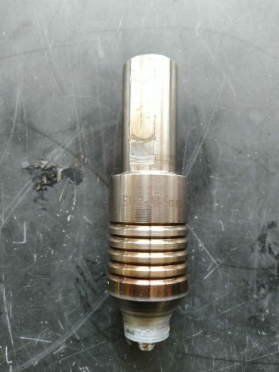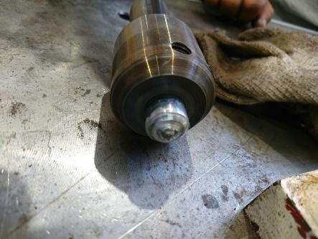
b
a
Fig 2: (a) Stainless steel threaded pin & (b) tungsten rhenium threaded pin
2.2. Friction Stir Welding (FSW)
The specimens for the main materials, AA6062 are cut into dimension of 100mm x 150mm with thickness of 6.35 mm while for the filler materials (AA7075, Copper C1100 and AA1100) were cut into 3mm x 150mm x 6.35mm. The fillers were cut by using Electrical discharge machining (EDM). The FSW process were run according to the parameters that have been set for this process as per TABLE 4.
Table 1: Parameters of the FSW process

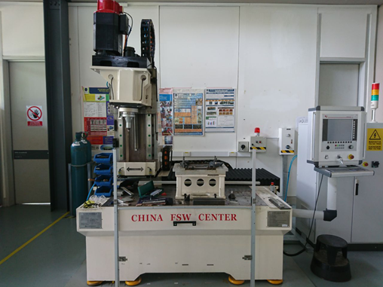
Fig 3: FSW machine
2.3. Microstructural Examination
Several steps need to be done before executing the microstructural examination. The specimen will be cut half perpendicular to the direction of the welding, after that, the specimen needs to undergo grinding process. The dimension of the samples is in square shape which is 20mm x 20mm and cut by using EDM wire cut machine. The prepared samples for microstructural test need to be mounted, grinded, polished and etched. Then, proceed with polishing process and etching.
The next process is grinding. 4 grades of sandpapers are used for the purpose which starts with P600, P800, P1200 and P1500 accordingly. The rotational speed of the grinding if fixed at 250 rpm. Next step was grinding and polishing process in the material lab. After finished with grinding, the samples were polished to make the surface smoother and mirror-look. The polishing agents that were used are MetaDiTM Supreme of 9micron meter, 6micron meter and 3micron meter. The polished surfaces are kept carefully as to prevent from any scratch or damage during microstructural examination.
The process continued with etching process. This process obeyed Kellers Etch as the material used for this project is aluminium alloy. The composition of the solution consists of 190ml of distilled water, 5ml of nitric acid, 3ml of hydrochloric acid and 2ml of hydrofluoric acid. The samples are then immersed for 30 seconds in the mixture. The process continued with heating to dry up the sample surfaces
2.4. Tensile Testing
Tensile strength testing is needed to determine the welded specimens. The test parameters will be following the sub size of ASTM E8-04. The test specimen will be cut using EDM wire cut machine as Fig 4 The tensile testing will be done using Ultimate Testing Machine (UTM). The specimens are set up at the UTM machine to test for its maximum strength before it breaks.
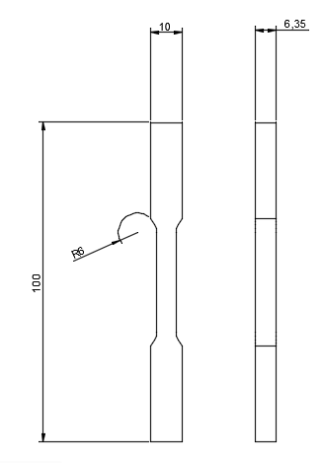
Fig 4: Dog bone specimen according to sub-size of ASTM E8-04 for tensile testing

3. Results and Discussion
3.1. Appearance of The Weld
Fig 5 shows the appearance of the welded samples of all the filler materials which are AA1100, AA7075 and Cu C1100. The most concern about this project is the filler material towards the appearance of the welded joint. As mentioned in the scope of study, the melting point of base metal, AA6061, is 582$℃.$While for the filler material AA7075, AA6061 and AA1100 are 483°C, 582°C and 643°C respectively. During FSW, both materials melt causes to weaken the interface, which hot cracking can occur along the interface during that process. As the unconsumable pin moved along the stirring zone (SZ), the melted materials were converted to brittle intermetallics which consists of high cold cracking sensitivity.
This issue much related to the appearance of the welds. Fig 5(a) and (b) show that the surface appearance of AA1100 filler and AA7075 filler have no obvious crack or gap within the welded zone. While for the copper filler, cracking can be seen clearly at almost along the stirring zone.

a

b

c

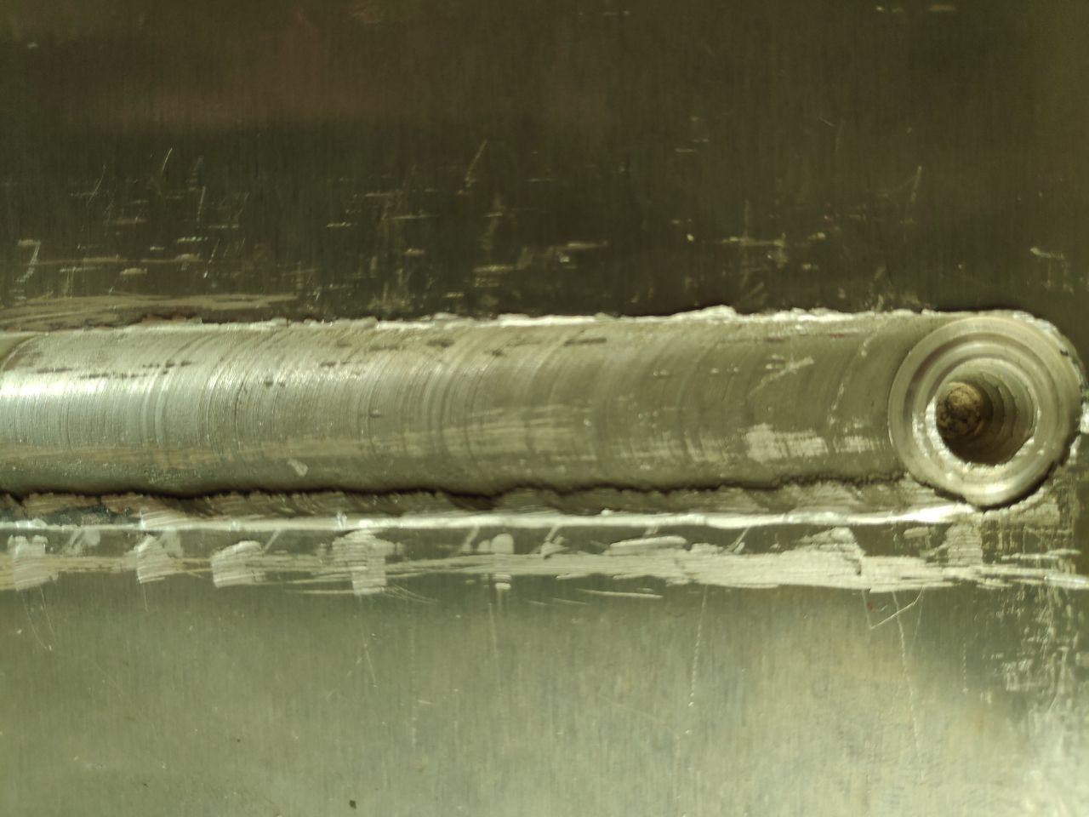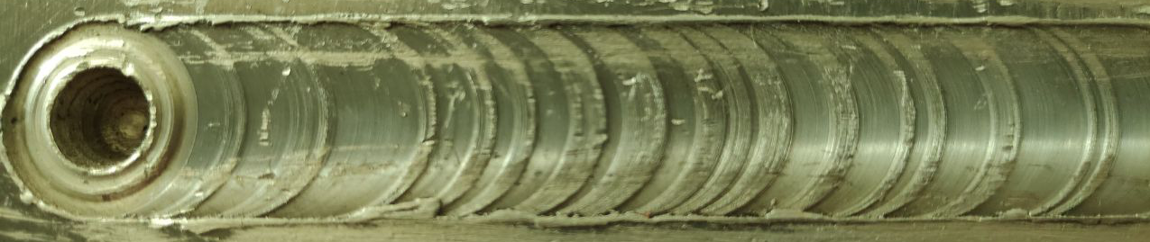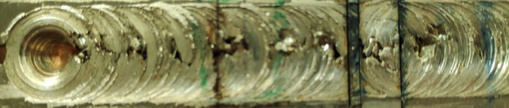
RS

AS
RS

AS
RS

AS
Fig 5: Surface appearance of welded samples of base metal, AA6061 and (a) AA1100 filler (b) AA7075 filler (c) Cu C1100
3.2 Macro and microstructural observation
The metallurgical structure of all the samples which were joined with the FSW method were examined in detail. In FSW joints, the structure composes of Nugget zone (NZ)/dynamic recrystallization zone (DCZ), thermo mechanically affected zone (TMAZ), heat affected zone (HAZ) and base metal (BM) were investigated in macro and micro size by using OM and SEM. Fig 6. shows the structure of the cross section of welded joint in FSW method.
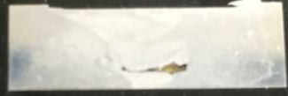
HAZ TMAZ DCZ TMAZ HAZ
BM
BM
Fig 6: Cross section of FSW welded joint
One of the objectives of this experiment is to examine the microstructure of the welded joint and base material in order to study the materials behaviour at the welded. The samples were examined using OM. Images of Macro and microstructure were taken from the cutaway surfaces of AA1100 filler and AA6061, AA7075 filler and AA6062, and Cu C1100 filler and AA6061 joined by using FSW method. Based on FIGURE 14 ,when the images of macro and microstructure were examined, the structure of DCZ, TMAZ, HAZ and porosity in the joint zones can be detected.
The structures formed depending on the manipulated variable which is filler material. The rotational speed and traverse speed were kept constant which are 800rpm and 15mm/min respectively. When the microstructure of the welded joint of copper filler was examined, wide gaps in the joining zones can be seen. While, when the microstructure of the joint of AA1100 filler and AA7075 filler were examined, less porosity at joining zones can be found.
According to Fig 7., when the base material, AA6061, joined with copper filler using FSW method, it was observed that gaps can be found at the DCZ zone either at the advancing side (AS), retreating side (RS), bottom part or middle. From the macro image of it, the black region indicates the gap/ porosity that filled with mounting compressed power during mounting process to prepare microstructure sample. As per mentioned image, the Cu particles occurred like copper islands that stacked in aluminium alloy region in the stir zone [7]. To join aluminium alloy and copper by using FSW is difficult due to formation of brittle and hard IMCs which the existence of them causes fragmented defects and reduces the quality of joint [8,9].
The grain boundaries that can be found at TMAZ near the DCZ has round-end shape or more like curvy end with less sharp edges. There is joining failure can be detected from the microstructure view as in Fig 7 (c).
When the AA1100 filler and base material, AA6061, were joined by FSW process, both materials were stirred much better and more ductile compared to copper filler. FIGURE 8 potrays the image of welded cross section where gaps can be found at the bottom of DCZ. The division of formed zones due to FSW method can be seen clearly which included DCZ, TMAZ, HAZ and BM. The region between DCZ and TMAZ can be differentiated as both regions indicates with different colour. The occurance of grain boundaries can be found at certain part at DCZ. It possesses sharp edges and square-like shape grain boundaries. For the welded joint between AA6061 and AA1100 filler, both materials were joined as good as AA1100 filler. Fig 9 shows the DCZ where the pattern of materials flow can be detected. The different melting point between AA1100 and AA6061 is 99$℃$ which contributes to perfect welded joint. Both materials melted at the same state of matter and after the tool movement passed the stirring zone, both materials combine nicely as they possess high cold cracking sensitivity.
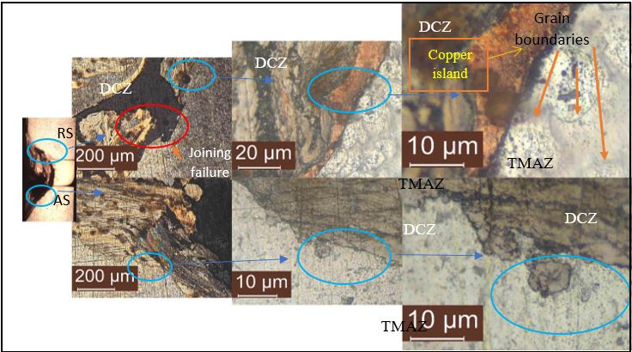
b)
a)
Fig 7: OM macro and microstructure of copper filler and AA6061 plates under a) 5x magnification b) 10x magnification & c) 100x magnification

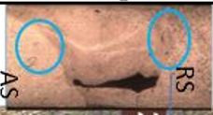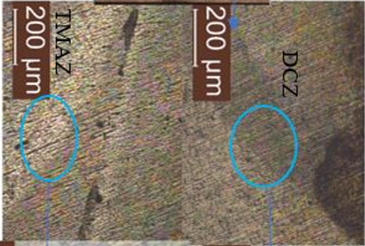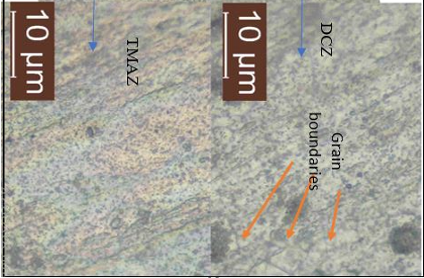
b)
a)
Fig 8: OM macro and microstructure of AA1100 filler and AA6061 welded joint under a) 5x magnification b) 10x magnification & c) 100x magnification
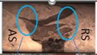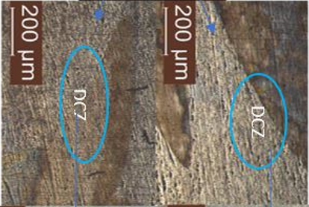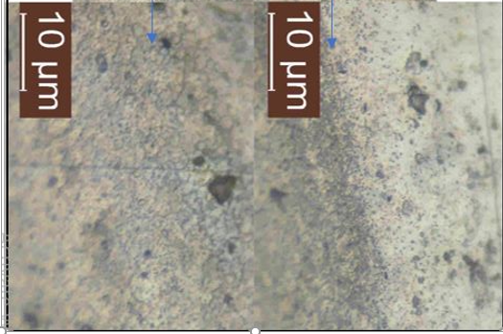
Fig 9: OM macro and microstructure of AA7075 filler and AA6061 welded joint under a) 5x magnification b) 10x magnification & c) 100x magnification
Fig 10 shows the welding quality of those samples which Figure 10 (a) is for copper filler, Fig 10 (b) is for AA1100 filler and Figure 10 (c) AA7075. For the Cu-AA6061 welded joint at NZ part, the image shows 2 major contrast of colour which indicates the diffusion between copper and AA6061. At side of RS, the materials at TMAZ experienced heat that was generated due to the rotation of tool in the stir zone but overall the material did not experience any recrystallization process. TMAZ area was recognized within the area below the tool shoulder. In addition, few joining failure can be seen clearly at the area of DCZ-TMAZ where porosity and improper welding was identified. The difference of microstructure appearance between TMAZ and DCZ are very contradict where DCZ area looks brittle and many micro cracking were formed while the other zone was vice versa.
For the TMAZ part at RS, the pores were smaller than in the DCZ that indicates that no recrystallization occur in that zone. When the base metal, AA6061, and AA1100 filler were joined by using FSW method, there was a gap occurred between the unwelded part and bottom part of the DCZ as per Figure 10 (b). The shape of the gap/hole is like converging from the retreating side to the AS due to the clockwise rotation of the FSW tool. Furthermore, several pores where detected at the DCZ area which from the scale given by the SEM software that the pores have dimension about 5micron meter in length which is smaller than the pore in the TMAZ part. This is due to recrystallization which causes the grains size to reform. Also, Figure 10 (c) shows the FSW joint between base metal, AA6061 and AA7075 filler. From the macro image, a big layer like onion-ring can be found which showing the movement of material in the nugget zone. For this filler material, the grain boundaries can be seen under magnification of 3000x at TMAZ of RS, DCZ and TMAZ-DCZ at AS area. At TMAZ of RS, the average size of the grain boundaries is about 4micron which some has round end and some have edges end. Meanwhile, at the nugget zone, the grain boundaries shape looks more like crystal form and more sharp edges compared to TMAZ area.
Under magnification above 3000x of all the 3 zones, there is no joining failure detected unless at the macro image between unwelded part and bottom part of the nugget zone.
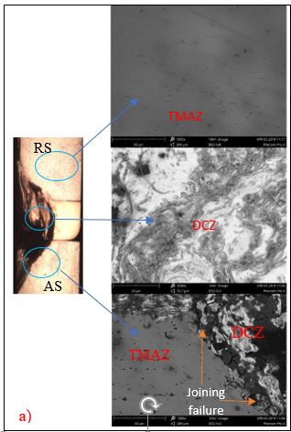

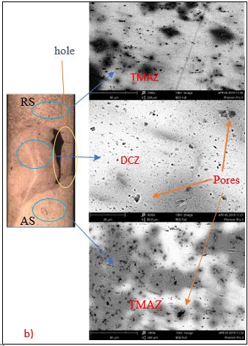
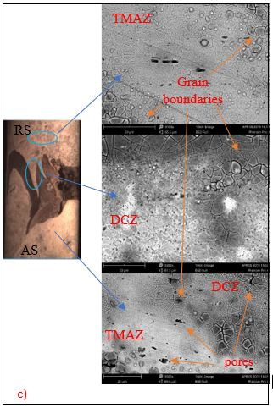
Fig 10: SEM images of the welded samples of base metal, AA6061, with a) Cu C1100 b) AA1100 c) AA7075
pores
TMAZ
c)

3.3 Tensile Strength Management
From the physical appearance of the tested sample, the breakpoint happened at the welded joint which the point to test for strength is legit and correct FIGURE 11(b). Table 2 shows the results of tensile testing for all the filler material joints. Besides, Fig 12 shows the curve of the graph as in the result occurred as it should be for dissimilar grade between aluminium alloys. As per the graph of stress against strain, the maximum stress that it obtained is 101.402Mpa with the strain of 8.804%. The maximum load that it can bear before it breaks is 3.863kN. the upper yield stress and lower yield stress is 1.391Mpa and 1.355Mpa respectively. The total energy of all the process reach up to 6.948kN-mm and the total energy under plastic region is 5.744kN-mm. according to the Fig 17(a), total elongation at break (using strain) is 8.804%. From this data, it can prove the objective to investigate the butt joint strength regards of welded joint of AA1100-AA6061 is achieved.
Table 2: Tensile testing result
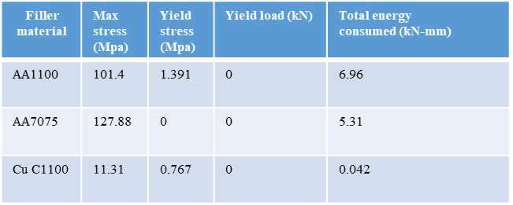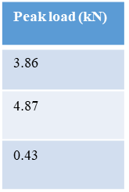
Fig 11 (a) portrays the physical appearance of the AA7075-AA6061 tested sample. The sample breaks occurred as per plan which at the welded part where the strength that needs to be obtained is the strength of blended materials at nugget zone (NZ).
In addition, the graph of stress vs strain obtained shows less stiff compared to AA1100-AA6061 with higher peak stress which is 127.28Mpa. The maximum load obtained also higher that previously which is 4.872kN. This process consumed total energy of 5.311kN-mm and energy under plastic region is 4.253kN-mm. The total elongation at break (using strain) is 6.086%. Fig 12 (b) shows the graph of stress vs strain of joint between AA7075 and AA6061. Meanwhile, Fig 11 (c). shows the tested sample of welded joint between copper and AA6061. From view from naked eyes, the point of break is a little bit offset towards the retreating side (RS). From the welded part also, voids are obviously can be found which the materials cannot blended properly.
Fig 12 (c) shows the stress vs strain graph of Cu C1100-AA6061, the point of break happened at the RS side in the nugget zone. The peak stress obtained is lower compared to both of previous samples which only 11.308MPa. The peak load that this sample can withstand before it breaks is 0.431Kn. The upper and lower yield stress are 0.767MPa and 0.746MPa respectively. Total energy that needed to break the joint is 0.042kN-mm and energy under plastic region is 0.035kN-mm. It proves that the joint of those materials are not flexible and become brittle due to the large grain boundaries occurred which both materials cannot hold each other and slipped when there is force applied that exceed 0.431kN. The total elongation at break (using strain) is 0.569%.

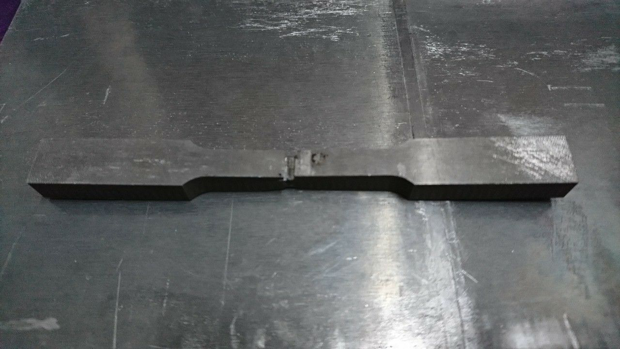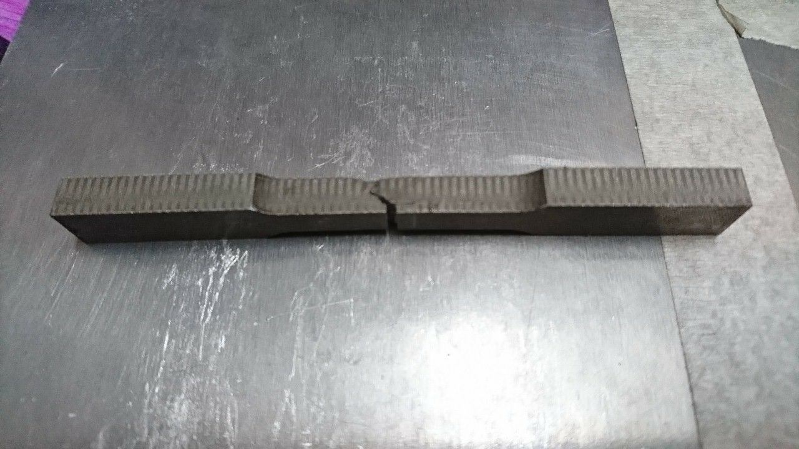
(a)

(b)

(c)
Fig 11: Tested sample of (a) AA1100-AA6061 (b) AA7075-AA6061 (c) Cu C1100-AA6061

(a)

(b)

(c)

Fig 12: Graph of stress vs strain of welded joint between a) AA1100 and AA6061 b) AA7075 and AA6061 c) Cu C1100 and AA6061
As per Table 3, the similar material tensile strength to be compared with AA1100 filler-AA6061, the dissimilar grade of AA achieved 24% from the similar joint which drop 76% of tensile strength. For the dissimilar AA yield strength, it is only 0.37% compared to the similar joint strength. But for the elongation of the dissimilar joint, it goes to 4% elongation compared to the similar joint which is 6%. Furthermore, the welded joint between AA7075 filler and AA6061 tensile strength dropped 70% from the strength of similar joint. For the yield strength, the dissimilar material obtained 0MPA. The total elongation before breaks is 8.804% which 46% more than the similar joint. In addition, for the welded joint of Cu filler and AA6061, the tensile strength dropped 97.3% compared to the similar material joint. While for the yield stress, it dropped about 99.8% and only obtained elongation for 0.569% compared to the similar joint which is 6% (90.5% drop).
Table 3: Comparison of the results with the similar joint material which is AA6061.
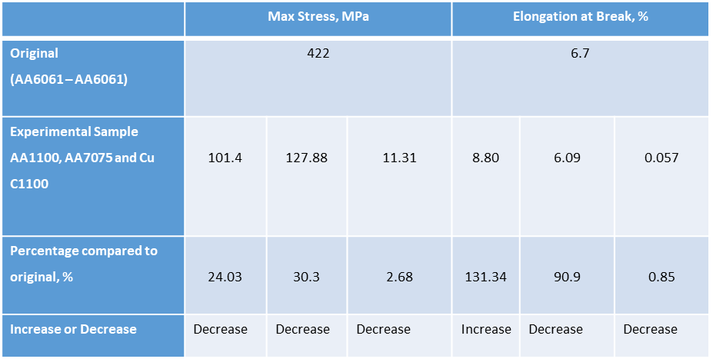

4. Conclusion
FSW of parent materials towards the filler materials of AA1100 and AA7075 are blended properly due to close range of melting point and the materials can penetrate well in the nugget zone. The materials distribution in the nugget zone is hard to be detected by using naked eyes and need to use Optical Microscope (OM) and Scanning Electron Microscope (SEM) to see those 2 materials behave in the welded area.
For the dissimilar between Cu C1100 and AA6061, the results shown that this combination obtain the least strength among all due to different in melting point that caused macrocrack and microcrack. The crack formation is visible on the weld surface. Poor metallurgical bonding in the nugget zone is an additional reason to this problem. Of all the maximum stress for every filler material, AA7075 gave the highest and Cu C1100 filler was at the last place in joint strength.
Based on the results that obtained from this experiment, it can answer to the objectives of this project which relate with the problem statements.
5. Recommendation
Further study is hoped to be done in the future in order to obtain the correct parameter and process in order to ensure the dissimilar material between Al and Cu can be welded perfectly.
Acknowledgement
I have taken efforts in this project. However, it would not have been possible without the kind support and help of many individuals and organizations. I would like to extend my sincere thanks to all of them. I am highly indebted to Assoc. Prof. Ir. Dr Mokhtar bin Awang for his guidance and constant supervision as well as for providing necessary information regarding the project & also for their support in completing the project. I would like to express my gratitude towards my parents for the encouragement which help me a lot in completion of this project. I would like to express my special gratitude and thanks to the technician, Mr Hafiz for giving me such attention and time during my project. My thanks and appreciations also go to my colleague which have willingly helped me out throughout the project.
References
[1] THOMAS W M, NICHOLAS E D, NEEDHAM J C, MURCH M G, TEMPLE-SMITH P, DAWES C J. Friction welding [P]. US Patent 5460317. 1991
[2] X.-G. Chen, R. Hark, in: W. Yin, S.K. Das (Eds.), Proceedings of Aluminum Alloys: Fabrication, Characterization and Applications, TMS, 2008, 3–9.
[3] SINGH H, ARORA H. Friction stir welding−Technology and future potential [C]//Proceedings of National Conference on Advancements and Futuristic Trends in Mechanical and Materials Engineering. Tangori, Mohali, Punjab, India, 2010: 32−38.
[4] MUBIAYI M, AKINLABI E. Friction stir welding of dissimilar materials between aluminium alloys and copper, An overview [C]//Proceedings of the World Congress on Engineering. San Francisco, USA: IAENG Publications, 2013: 3−5.
[5] LIENERT T, MISHRA R, MAHONEY M. Friction stir welding and processing [M]. Materials Park, OH: ASM International, 2007: 123−154.
[6] NANDAN R, DEBROY T, BHADESHIA H. Recent advances in friction-stir welding–process, weldment structure and properties [J]. Progress in Materials Science, 2008, 53(6): 980−1023.
[7] THOMAS W, NORRIS I, STAINES D, WATTS E. Friction stir welding Process developments and variant techniques [J]. The SME Summit, 2005, 1(1): pp 1−21.
[7] Sharma N., Khan Z.A., Siddiquee A.N. Friction stir welding of aluminium to copper- An overview. Trans. Nonferrous Met. Soc. China 27(2017), pp 2113-2136.
[8] GALVAO I, OLIVEIRA J, LOUREIRO A, RODRIGUES D. Formation and distribution of brittle structures in friction stir welding of aluminium and copper: Influence of process parameters [J]. Science and Technology of Welding and Joining, 2011, 16(8): pp 681−689.
[9] GENEVOIS C, GIRARD M, HUNEAU B, SAUVAGE X, RACINEUX G. Interfacial reaction during friction stir welding of Al and Cu [J]. Metallurgical and Materials Transactions A, 2011, 42(8): 2290−229.

